**INDIVIDUAL ANALYSIS REPORT**

Group C1.04.05

07/03/2023

Author(s):

Carlos Bermejo Soria,[*carbersor@alum.us.es*](mailto:carbersor@alum.us.es)

**Table of contents**

**Table of contents** **2**

**1. Executive summary** **3**

**2. Revision table** **3**

**3. Introduction** **3**

**4. Contents** **3**

4.1. Performed tasks 3

4.2. Budget 4

**5. Conclusions** **4**

**6. Bibliography** **4**

1. **Executive summary**

This report summarizes the analysis needed for the second deliverable for Carlos Bermejo Soria’s work.

1. **Revision table**

| **No** | **Date** | **Description** |
| --- | --- | --- |
| 1.0 | 07/03/2023 | Initial draft of the document. |

1. **Introduction**

The analysis of the requirements is fundamental in every project to get the necessities of the customer right and understand the domain with precision. The documents provided to us already give a detailed expression of what the requirements might be and what they need to be completely fulfilled. If any of those requirements implores extra analysis it will be documented on these analysis reports throughout the different deliverables of the project.

1. **Contents**

This delivery required some analysis for the correct understanding of the requirements. Each of these decisions were taken having in mind the comments in the forum and the teacher’s advice.

**4.1. Requirements**

* **RI 04.** The expertise fields from an assistant cannot be saved as a list of String objects, so I decided to interpret a single String as many values separated using the *\n* character.
* **RI 05 (1).** I deduced from the text that every tutorial needed a session and sessions can’t exist if there is no tutorial assigned, so the relation between both entities should be a composition.
* **RI 05 (2).** Since a tutorial is made by a specific assistant (as deduced from the requirement regarding the assistant dashboard, where it implicitly says that an assistant needs data from his or her specific tutorials), there must exist a relation between both entities.
* **RI 05 (3).** The estimated time could be represented in many different ways but I decided to follow the client’s recommendations and save it as a number where the integer part is the number of hours and it’s limited to 3 digits, and the decimal part is the percentage of an hour and it’s limited to 2 digits.
* **RI 05 (4).** The different goals will be saved in a single String attribute separated using the *\n* character.
* **RI 06.** Since a session can be one of two different types of session, I decided that a boolean field would not be easy to understand and instead decided to use an enumerate class including both session types THEORETICAL and HANDS-ON (and an extra type BALANCED to be used in other context).

**4.2. Diagrams**

For this set of requirements I decided to make an individual UML model to represent each of the entities and classes needed for the deliverable, including their attributes, relations and restrictions.

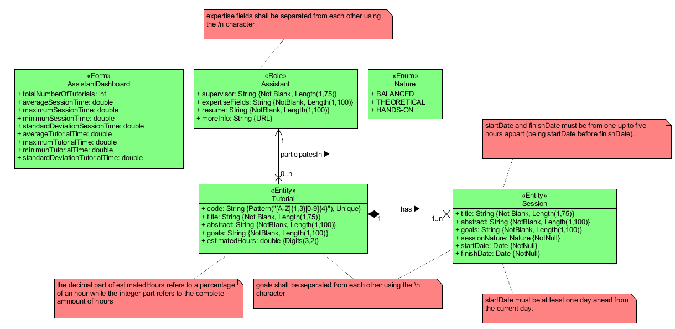

1. **Conclusions**

These were the overall details of the performed individual task by the member Carlos Bermejo Soria.

1. **Bibliography**

<Intentionally blank>